Chapter 11, Problem 60.

For the circuit in Fig. 11.79, find V_{o} and the input power factor.

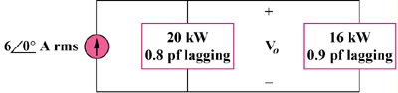

Figure 11.79
For Prob. 11.60.

